PROJECT PROGRESS:

I have developed a previous model topology by including new routers and servers for HTTP and DNS and configured all the pcs and servers and routers respectively. Also, I have verified that DNS and HTTPS services are working and verified through the simulation I have done and screenshots below displays the topology diagram connections also configurations are done for all pcs by assigning ip addresses for all and results are shown with the message travelling images and verified image as well. Initially when requested from the pc it first goes to the http server and comes back to pc after been verified. All time taken travelling through switches and router path is shown in the last screenshot image as well.

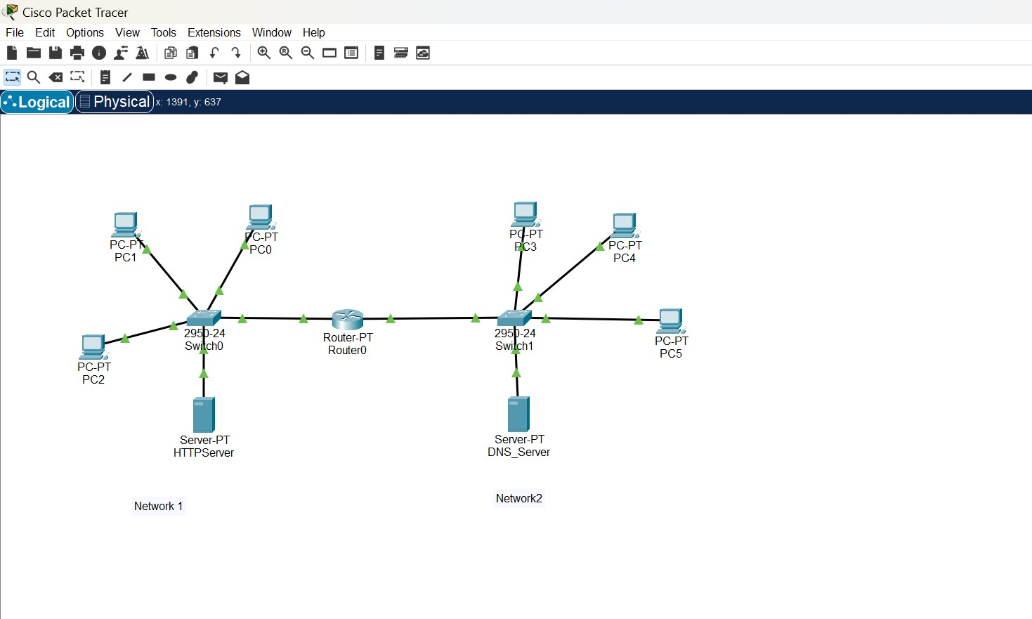

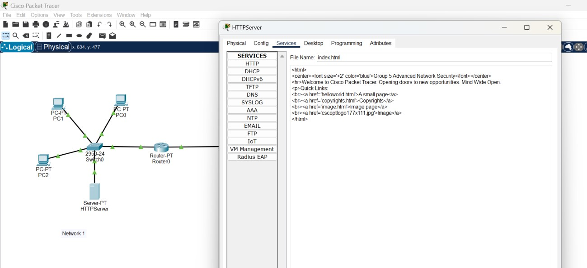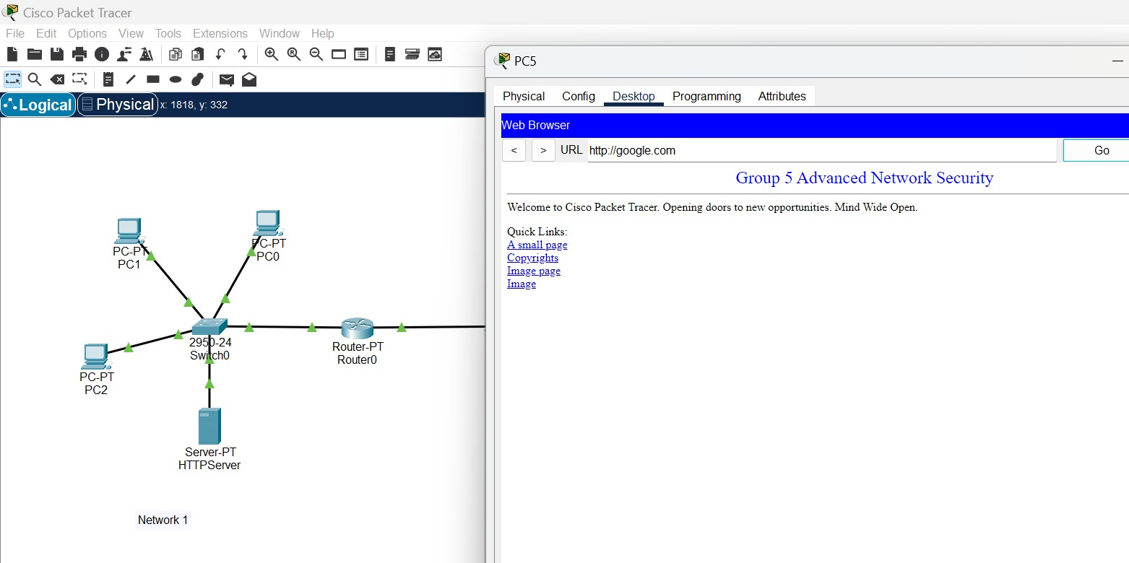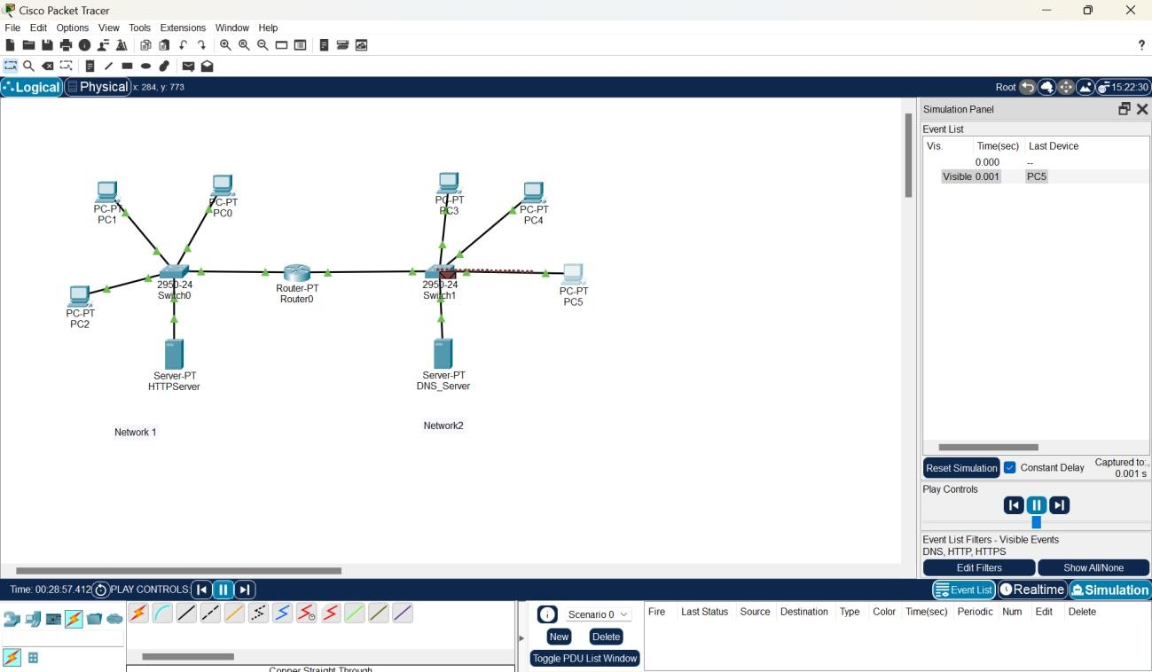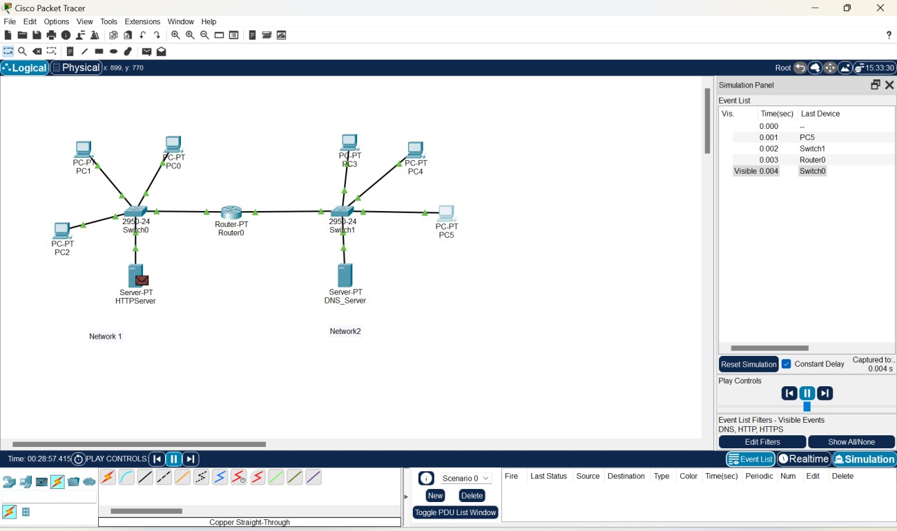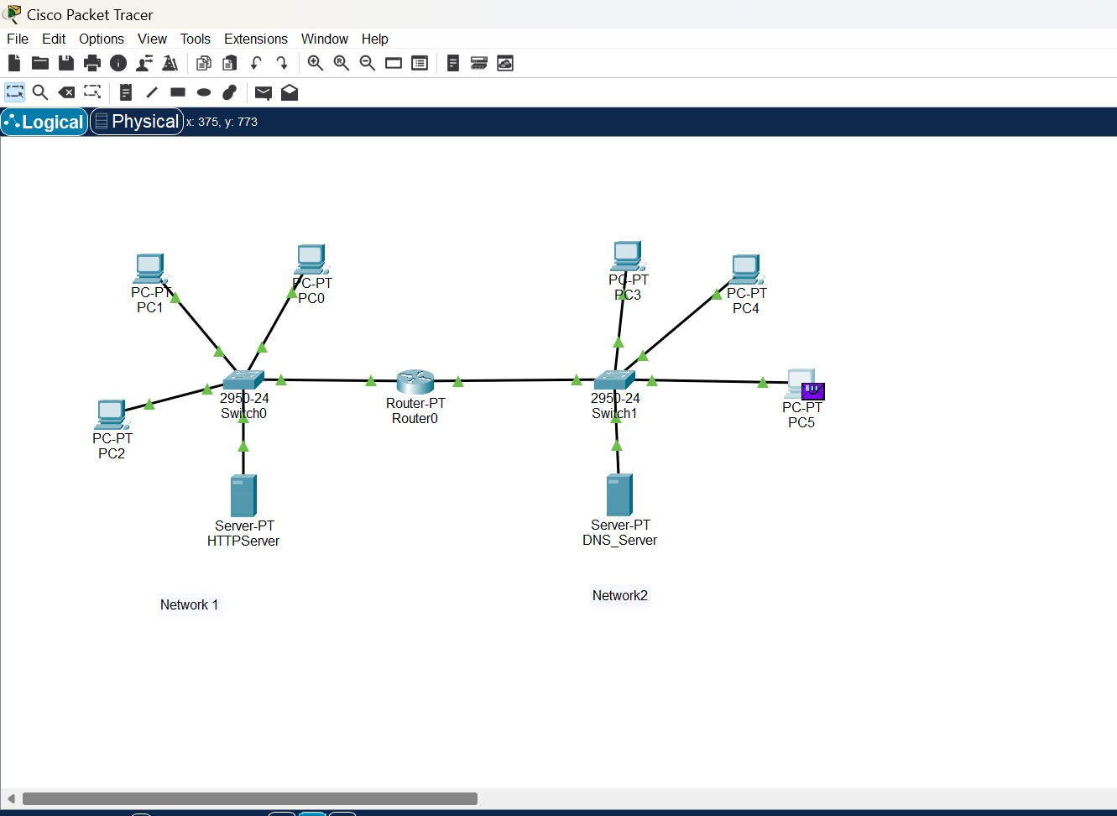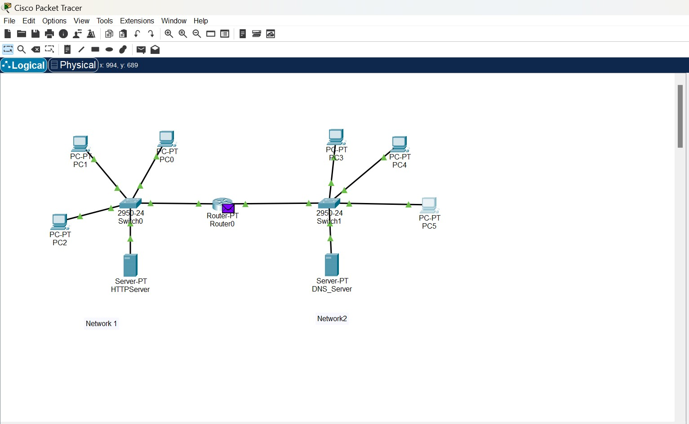

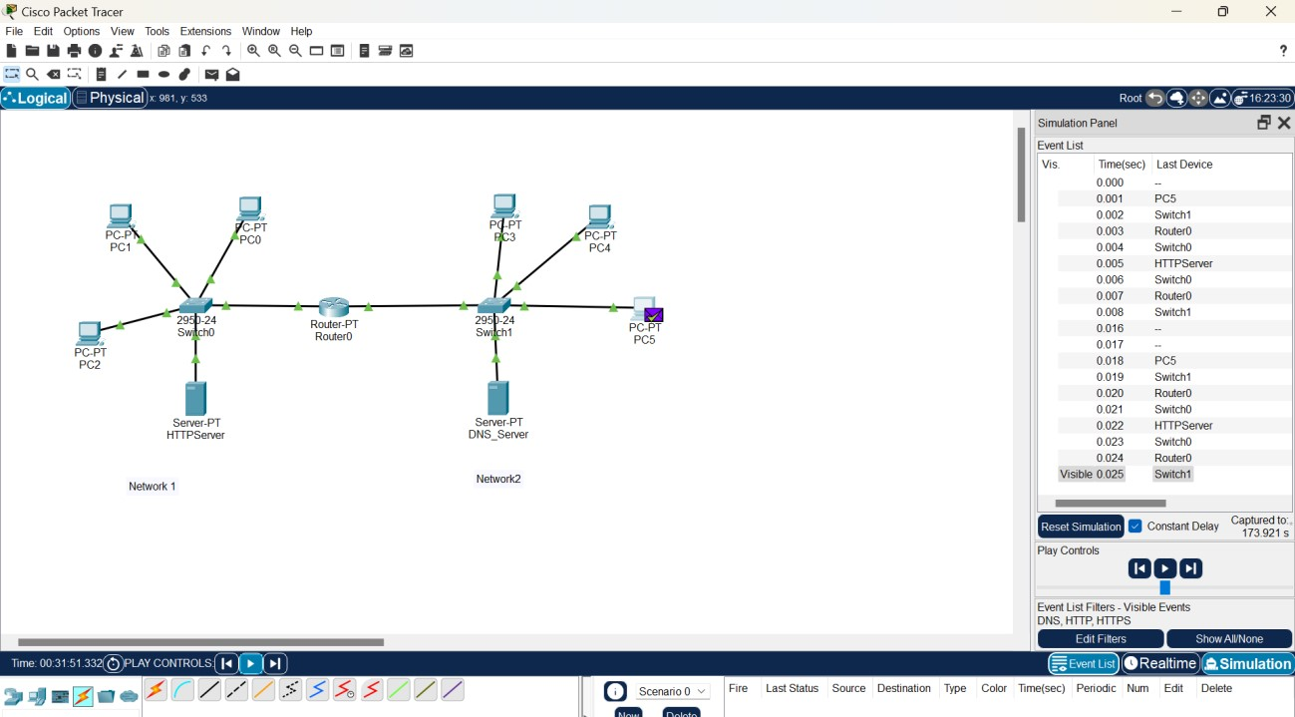

The above screenshot shows the message being verified and simulation panel shows the path where the message has been travelled.